The Story of Saturday, September 9th, 8:55 PM start [A Day Interconnected by Divinity] Japan time

Beginning sentences of the email
This week, we will discuss as follows.
What is Illness from the Perspective of the Divinity?
What is Aging from the perspective of divinity?
What is abundance from the perspective of divinity?
What is Happiness from the perspective of the divinity?
What is the family from the perspective of the divinity?
In these ways, we will look at ourselves from the perspective of divinity and the connection of life within the self.

First, we will look back at the structure of the human soul.

[The Structure of the Human Soul]
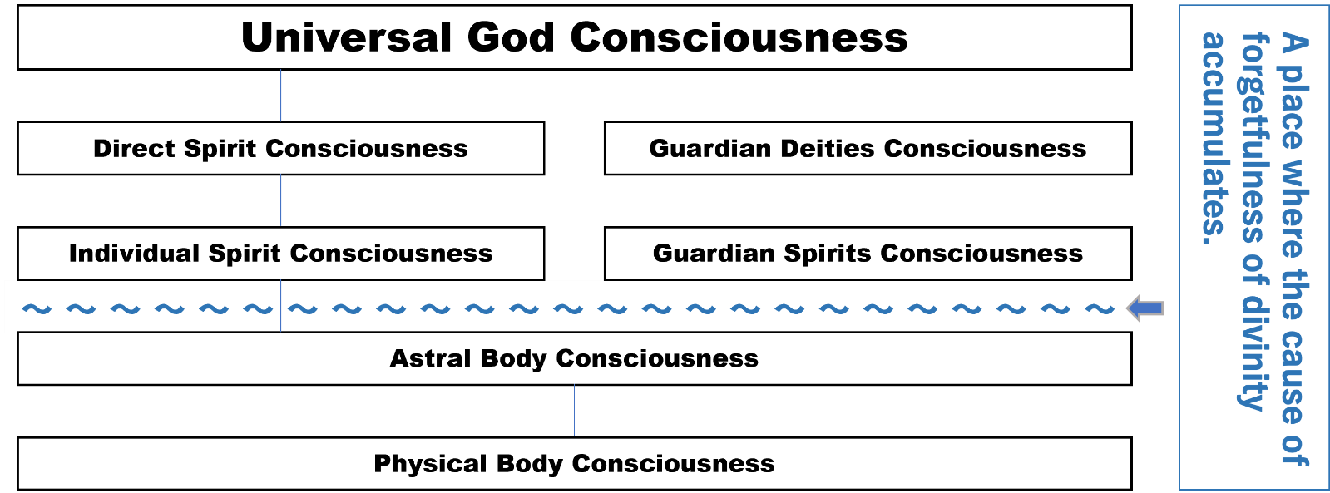
Subconscious Consciousness
As described above, human consciousness is composed of seven elements. However, until now, most people recognized only the lowest level, Physical Body Consciousness. To be more precise, until now, the human beings of the earth have been living under the control of the habit of forgetting the divinity, which has been accumulated in the astral body from past lives up to the present day. Because of this, we could not manifest the other five elements that lie deep within us.

This is because thoughts of self-limitation and self-negation were blocking the boundary between the astral and spiritual bodies (the sky of the astral realm deep within one's mind) like a black cloud. As a result, our minds were in a state where there was only Physical Body Consciousness and Astral Body Consciousness (manifest and subconscious), and for a long time, we humans wandered in a lost world as if we had forgotten the roots of life.

Guardian Deities and Spirits were a grace to humanity that had forgotten the path back to the roots of life. It can be said that their consciousness is a "bypass of life" that leads to the Source of Life, as in "Physical Body Consciousness - Astral Body Consciousness - Guardian Spirit - Guardian Deities - Divine Consciousness of the Origin (Universal God Consciousness). This other path should be able to allow humans to manifest our unlimited capacity and awaken as an integrated sevenfold consciousness. Still, many who have practiced it have felt that even that method was difficult.

But that aspect changed on July 2, 2017, with the Divine Spark IN coming down to earth. This is because it is now possible for each of us to directly connect with the source of life by performing this IN. (Needless to say, this is only possible with the help of the Guardian Deities and Spirits.)

The Third Way to Awaken the Sacred. 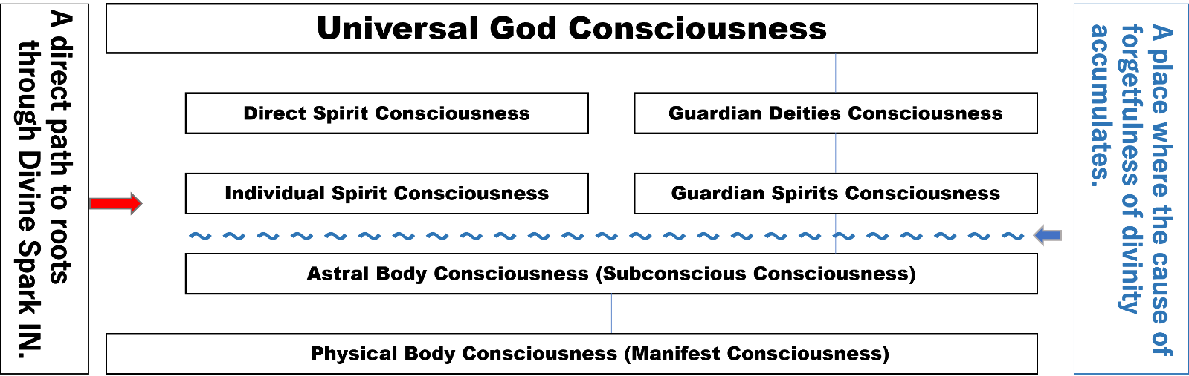
Since the Divine Spark IN has been used on earth, no matter how much self-limitation or self-denial remains in a person, the mystical power of the Divine Spark IN has made it possible to dimly recall Divine Consciousness even if the two paths on the right above have not yet been opened. I say "dimly" because this alone is far from the perfection of the personality and the integration of the soul.

What is important, therefore, is to seriously apply the traditional method of "living in oneness with Guardian Deities and Spirits" with the help of Divine Spark IN. In the daily practice of Divine Spark IN, we can easily achieve oneness with our guardian spirits and guardian deities. I say this because the path of direct connection with the source of life has been opened, and you can now intuitively know what you need to do to become one with your Guardian Deities and Spirits.

The simplest and most concrete way to do this is to be grateful to Guardian Deities and Spirits all day. Expand that and live in gratitude to all people. Expand it further and live in gratitude for everything. (If you play the role of a single-mindedly grateful person before you know it, you will turn into a truly grateful person.)

Then, the second passageway of "physical body - astral body - guardian spirit - guardian deities - universal god" will be opened. When this second passage opens, the first passageway, "physical body - astral body - spiritual body - divine body (direct spirit)- universal god," also opens automatically. It will happen before we know it.

As you become aware of the connections between the various elements within the soul, you will find yourself looking at yourself and others from the perspective of the divinity, and you will find yourself looking at the world from a bird's eye view without even knowing it.

That is how to grasp the answers from the perspective of divinity to some of the questions I wrote about at the beginning of this article. Then, you can find the essential meaning in all situations and events. (To help you put this into practice, I have included "Five Simple Rules for Ordinary People" at the end of this article.)

On Saturday evening, let us emit the light of life by being aware of the vertical connection of the spiritual lineage within ourselves and let our light transcend dimensional barriers.

The simple way for ordinary people to become one with the Divinity and the Self
(1) Thoroughly know that you cannot do anything with your Physical Body. (When you know this, it is the same as being enlightened, the GOI-sensei said.)
(2) Whenever you feel that you are not good enough, immediately think of it as the fading away of the causality of your past lives and pray for world peace.
(3) Pray tirelessly and always.
(4) Think that it is not you who does everything, but your Guardian Spirit and Guardian Deities who do it.
(5) Pray when you wake up in the morning and take some time to pray before going to sleep at night so that your breath will naturally settle in Lower Dantian.

-End-

Opening Remarks of Session
Hello everyone. Let's start the Zoom prayer meeting. In yesterday's e-mail, I wrote, "The shortest way for us to become aware of the "connection of life" in our hearts is to unite with our guardian spirits and guardian deities seriously and to make the divine perspective our own.

As a concrete way to achieve this, I recommended a life of gratitude for everything. I also introduced the Five Articles of the Ordinary People. I will introduce some of my own experiences behind this.

The "New Year's Guidelines" in 2007 hit me like a huge iron hammer to the head. It said something like this: "Your karmic thoughts are too much. Reverse your karmic intentions all your life."

Others laughed at me, and I rebuffed her, but I could not say anything more because it was written correctly. From that day on, I spent the next three years in a depressed state of mind, but in the fall of 2010, I received a revelation from my guardian god in Hiroshima during a six-month business trip there.

It was the following words: "Say 'Thank you' to everyone," and simultaneously, "Breathe slowly every waking moment." It was a very strong, silent sound that echoed through my brain.

I said, "No, I can't do it," his voice was even stronger, sounding irrefutable, and he said, "Don't be a bitch about it. Don't be a bitch about it, do it. Don't be afraid to say "Thank you" to anyone with a smile and a soft voice, even if you swear, "Why should I be thankful to this person? Finally, he admonished me to do so, and I did it.

At the time, I was grateful to nature and all living things, but I was not grateful to the people I interacted with, and I think that is what Guardian Deities and Spirits was trying to strengthen. Thanks to my guardian spirits and guardian deities' help, the sound of gratitude now surrounds me; I feel closer to my guardian spirits and deities and live a life that never ceases to bring me awareness.

Today, I would like to open the absolute connection with the Guardian Spirits and Guardian Deities by echoing the words of "Arigatou gozai-masu. (Thank you so much)," and as if looking down on all situations on the earth and various thoughts about them from above, I would like to look at even the thoughts of blame, condemnation, and evaluation like flowing clouds, transcending the barriers of dimensions and Let us release the light of the source of the universe.

It's time to begin the World Peace Prayer in Japanese and English. After that, please close your eyes and meditate for one minute, placing your consciousness in a Divine Perspective. And when I say, "Hai, arigatou gozai-masu," open your eyes. Then, let's get started.

-End-

